**FPT ACADEMY INTERNATIONAL**



## FPT – APTECH COMPUTER EDUCATION

RHYTHM HOUSE

|  |  |  |  |
| --- | --- | --- | --- |
| **Center Name** | | FPT – Aptech – HCM2  Address: 590 Cach Mang Thang Tam, District 3, Ho Chi Minh City | |
| **Instructor** |  | Ms. Le Mong Thuy |  |
| **Class** |  | T1.2002.E0 |  |
| **Group** |  | 5 |  |
| **Group members** | | **Name** | **Student ID** |
|  |  | Phạm Đăng Khoa | Student1256054 |
|  |  | Vũ Quang Đạt | Student1248885 |
|  |  | Nguyễn Phước Vĩnh Huy | Student1254039 |
| **Duration** | Start date | 15th June 2020 |  |
| End date | 22th July 2020 |  |

**This is to certify that**

**Mr.:**

Phạm Đăng Khoa

Vũ Quang Đạt

Nguyễn Phước Vĩnh Huy

**has successfully designed & developed**

eProject: Rhythm House website

**Submitted by:**

Pham Dang Khoa

**Date of issue:**

**Authorized Signature:**



**TABLE OF CONTENTS**

FPT – APTECH COMPUTER EDUCATION 1

ACKNOWLEGMENT 4

SYNOSIS 4

PROBLEM DEFINITION 4

CUSTOMER'S REQUIREMENTS SPECIFICATIONS (CRS) 5

Business/Project Objective: 5

Hardware/ Software Requirements: 6

SCOPE OF THE WORK (IN BRIEF) 7

Architecture and design of the system 8

Diagram of the website 9

TASK SHEET REVIEW 1 10

SITE MAP 11

MOCK OF THE WEBSITE 12

**1.** **Homepage** 12

**2.** **Shop** 13

**3.** **Membership** 14

**4.** **Blog** 15

**5.** **About us** 16

**6.** **Contact us** 17

**7.** **Log in** 18

**8.** **Register** 19

**9.** **Cart** 20

**10.** **Check out** 21

TASK SHEET REVIEW 2 22

WEBSITE DESCRIPTION 23

**1.** **Home Page** 23

**2.** **Shop** 25

**3.** **Membership** 26

**4.** **Blog** 27

**5.** **About us** 29

**6.** **Contact us** 30

**7.** **Log in** 30

**8.** **Register** 31

**9.** **Cart** 32

**10.** **Check out** 32

TASK SHEET REVIEW 3 34

# ACKNOWLEGMENT

On behalf of all the members of group 5, I would like to thank you all for the hard works, supports to make this eProject complete successfully. Especially, Ms. Le Mong Thuy, our teacher, she helped us a lot from the day that we started to study at FPT Aptech. With this eProject, she has guided us with her enthusiasm and rigorous, because of her guiding, we would be able to finish this project. Besides, I want to thank all the team member of group 5, each of the team member has been working continuously in 4 weeks in order to complete this project. The last but not least, we would like to say thank you to our family for always supporting us, creating the best conditions for us to focus on the project, and putting faith in the dreams we pursue.

# SYNOSIS

We need to create a website that meet all the requirement of our customer, Rhythm House. Rhythm House is a music store that not only provide music but also contest and live music. They have a big collection about books and magazines as well. The main purpose of this website is to reach to the customer, who have interest in music and looking for a place that they can live with their passion. Come to Rhythm House, customer can also be a member that has a lot of discount and special offer.

# PROBLEM DEFINITION

Rhythm House is a music store in the city which offers not only music but contests and live shows too. It caters to almost all the age groups by providing the CDs, tapes of poems for kids, latest pop music collection for teenagers, etc. Rhythm House also caters to a slightly older age group and boasts of the largest collection of regional and devotional music. Besides, if someone wants to pick up a good 60's or 70's rock album, chances are that he will get it here, and in case it’s not available, they will order it within a week.

They have the largest tape collection one can find ranging from Motion Picture Soundtracks to Rock 'n Roll. Besides music, one can find a number of music related magazines on sale. While some magazines are Indian, most of them are Air Mailed from the US and include top magazines like Guitar Legends and Total Guitar.

They also have a membership facility where in you can enroll yourself against any purchase of Rs. 200 and for subsequent purchases you can avail of points and other offers.

Looking at the growing competition, they have decided to find an easy source to reach to the customer and the solution they thought of is of building a web site which will host all the information about their shop.

# CUSTOMER'S REQUIREMENTS SPECIFICATIONS (CRS)

**Client: Rhythm House**

### Business/Project Objective:

Rhythm House is a music store in the city. They are not only providing various genres of music, but also movies, books, magazines live shows. They want to build a website to easy reach and support their customers.

We are supposed to create a website for them with the below mentioned requirement specifications.

The website is to be developed for the Windows Platform using HTML5, JavaScript, Bootstrap, jQuery and Geolocation. The site should work well in all leading browsers including Chrome, IE, Firefox etc.

**Input to the system:**

* + - * Searching products based on movie, band, solo performer, release year.
      * Purchase, order products on website.
      * Register members on website.

**Output from the system:**

* A menu that will categorize all the functions of the site.
* Display the list of available albums category wise.
* Albums can be of movies or different bands or solo performer’s collections.
* Categories can be CD, DVD, Tape as well as movies, bands, Solo performers. E.g there can be CD of a movie as well as DVD and tape, all should be displayed separately.
* Perform the search based on a particular: movie, band, solo performer, release year.
* Display the statistics of albums sold monthly.
* Display the various offers/contests by the shop.
* Display the details (performer, time, duration, entry fee, etc.) of live shows.
* Give information about membership.
* Display the available books and magazines.
* Display the price list of the various items available in the shop i.e. (CDs, DVDs, Tapes, Books, Magazines).
* Display the schedule and details of upcoming live shows.
* Site should be able to provide brief introduction/history about the shop under About Us page.
* The location of the shop under Contact-Us page.
* Besides the above requirements, the site should have look and feel as per the industry standards.

**Process**:

* + - * Allows customers to join membership with purchase of Rs. 200 with many special offers.
      * Validate data input from users.

**Expected delivery date:** 22-July-2020.

**List of deliverables:**

* + - * Document Word.
      * User Guide.
      * Source code.

### Hardware/ Software Requirements:

* **For developer**

**Hardware**

* + Intel Pentium 4 processor or higher
  + 1 Gigabytes of RAM or higher

**Software**

* + Windows 7 OS or higher
  + Adobe Dreamweaver
  + Web browsers such as IE, Chrome or Firefox are supporting HTML5, CSS3 and Javascript.
* **For web users**

**Hardware**

* + Intel Pentium 4 processor or higher
  + 512 Megabytes of RAM or higher

**Software**

* + Windows XP OS or higher
  + Web browsers such as IE, Chrome or Firefox are supporting HTML5, CSS3 and Javascript.

# SCOPE OF THE WORK (IN BRIEF)

After a long and detailed discussion, our group has decided to create a website contain the following webpages:

1. ***Homepage***: Display information about newest-selling products, an introduction about Rhythm House.
2. ***Shop***: Display all available album based on category (CD, DVD, tape, movies, band or solo performer), books and magazines, live shows.
3. ***Membership***: Give information about membership
4. ***Blog***: Display contest, live show and upcoming event.
5. ***About Us***: Display the information of the company, clients’ review and about us.
6. ***Contact***: Display the address of the company, allow customers to request any information they want to Rhythm House.
7. ***Log in***: Allow users sign up or sign in to the website.
8. **Register:** Allow users to register membership.
9. ***Cart***: review orders and proceed to check out page.
10. ***Check out***: Display total bill and confirm order.

# Architecture and design of the system

Webpage request



Requested Page

**RENDERING**

**ENGINE**

**CSS CODE**

**HTML CODE**

**WEB SERVER**

**WEB BROWSER**

**CLIENT**

**SERVER**

# Diagram of the website

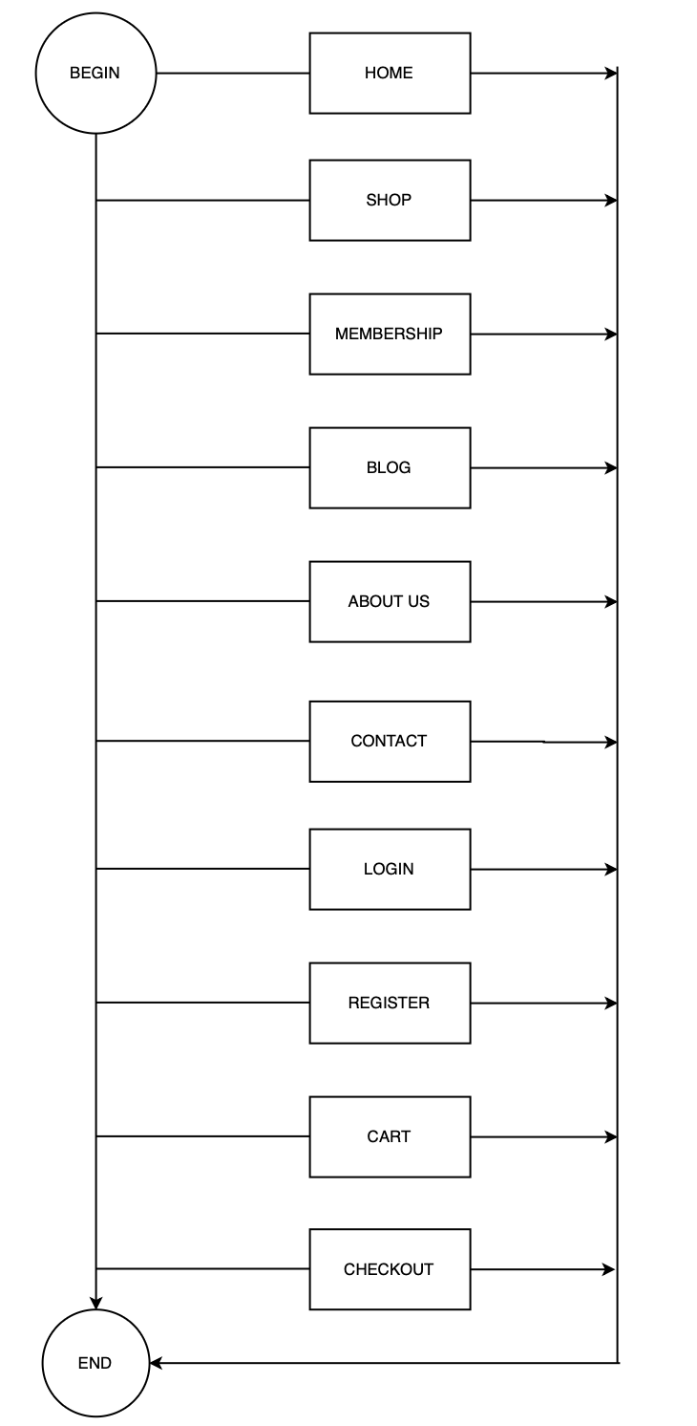



# TASK SHEET REVIEW 1

|  |  |  |  |  |  |  |  |
| --- | --- | --- | --- | --- | --- | --- | --- |
| **Project Ref. No.:**  **eP/Advertisement Portal Management**  **System/01** | | **Project Title:** | **Activity Plan Prepared By:** | **Date of Preparation of Activity Plan:** | | | |
| **Sr.**  **No.** | **Task** | **Actual**  **Start Date** | **Actual Days** | **Team**  **Mate Names** | **Status** |
| 1 | Problem Statement | RHYTHM HOUSE | Khoa | 15-June-20 | 1 | Dat | Completed |
| 2 | Analysis of Rhythm House requirements about the website | 15-June-20 | 1 | Dat | Completed |
| 3 | The scope of the work (in brief) | 15-June-20 | 1 | Khoa | Completed |
| 4 | Architecture and design of the system | 15-June-20 | 1 | Khoa | Completed |
| 5 | Diagram of the website | 15-June-20 | 1 | Huy | Completed |
| 6 | Task Sheet | 15-June-20 | 1 | Huy | Completed |

|  |  |
| --- | --- |
| **Date:** | |
| Signature of Instructor:  **Ms. Le Mong Thuy** | Signature of Team Leader:    **Pham Dang Khoa** |

# SITE MAP

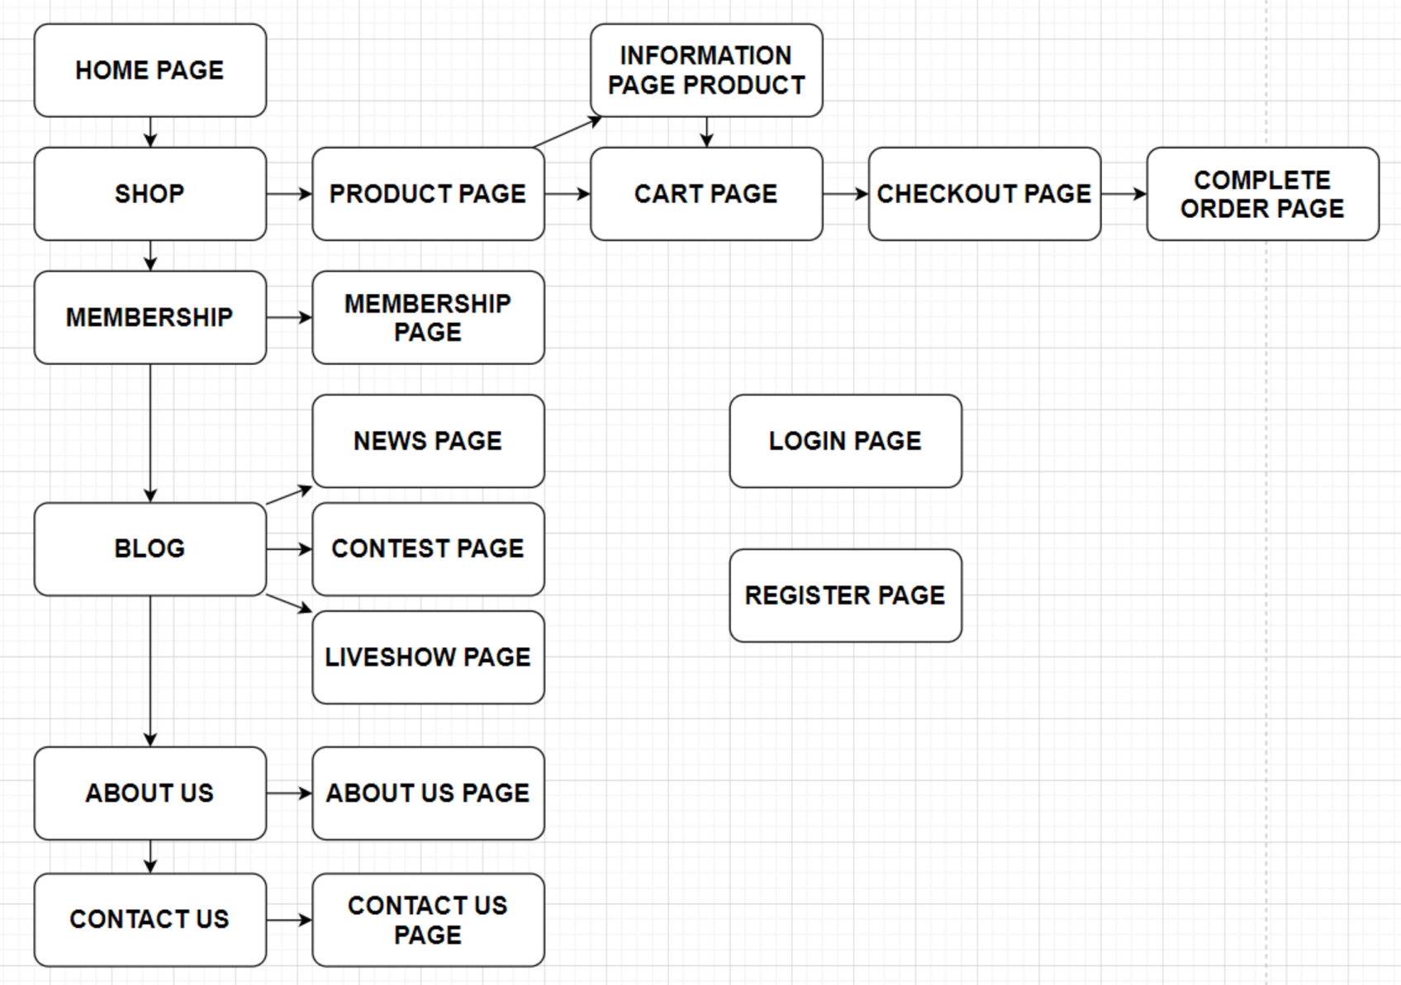

# MOCK OF THE WEBSITE

1. **Homepage**

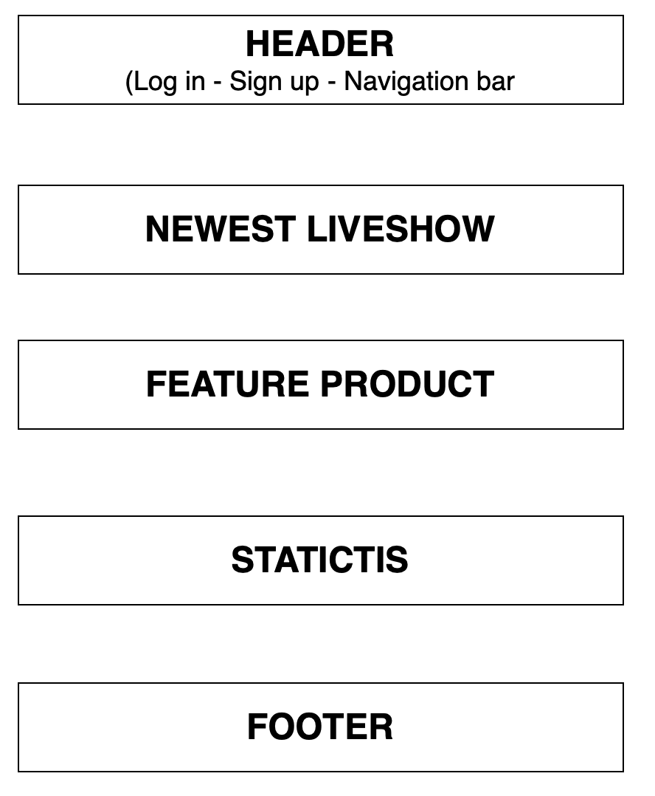

1. **Shop**

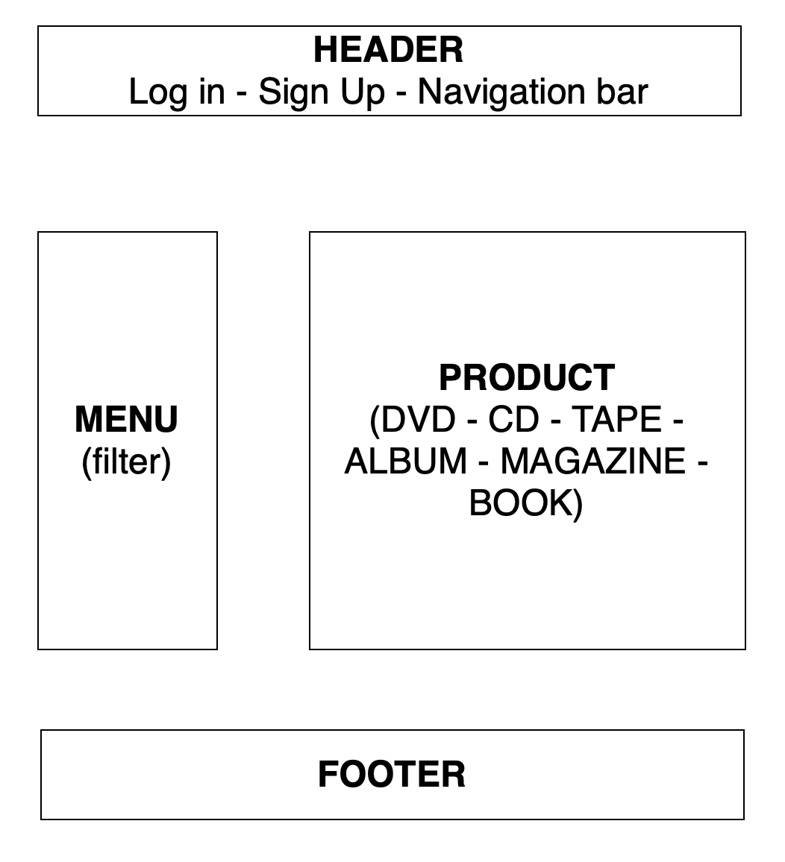

1. **Membership**

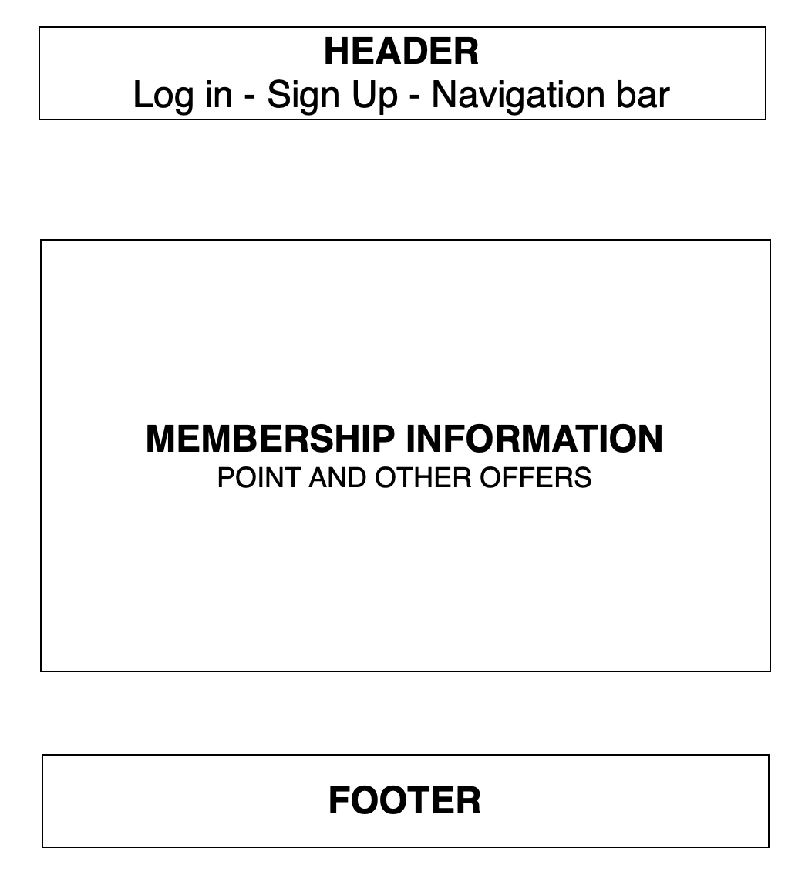

1. **Blog**

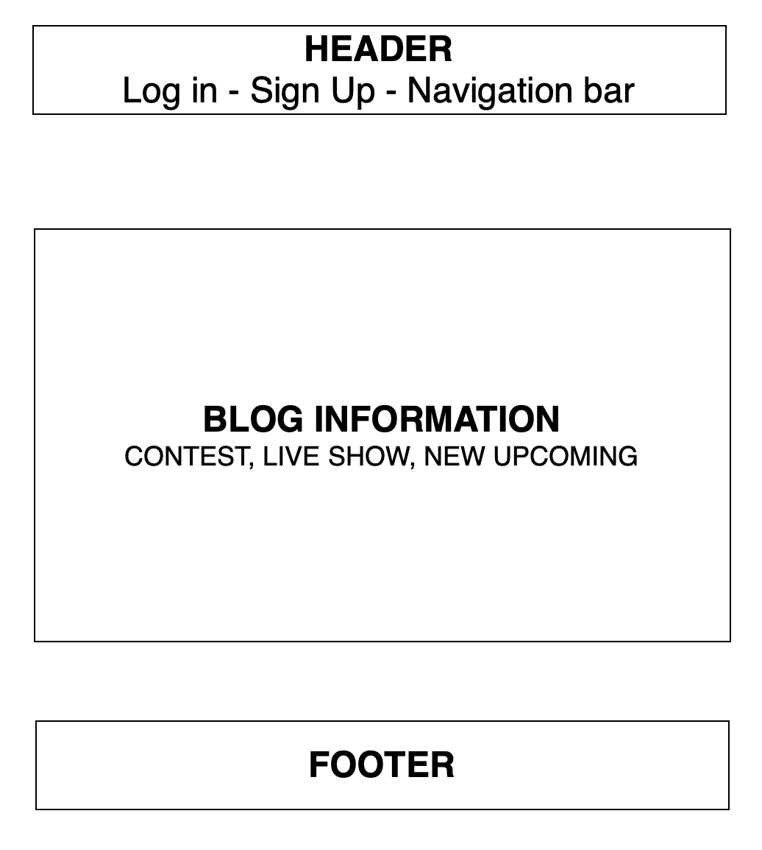

1. **About us**

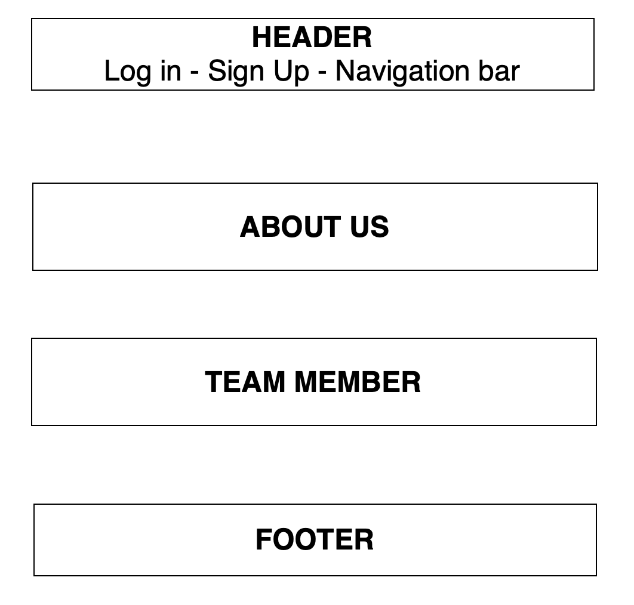

1. **Contact us**

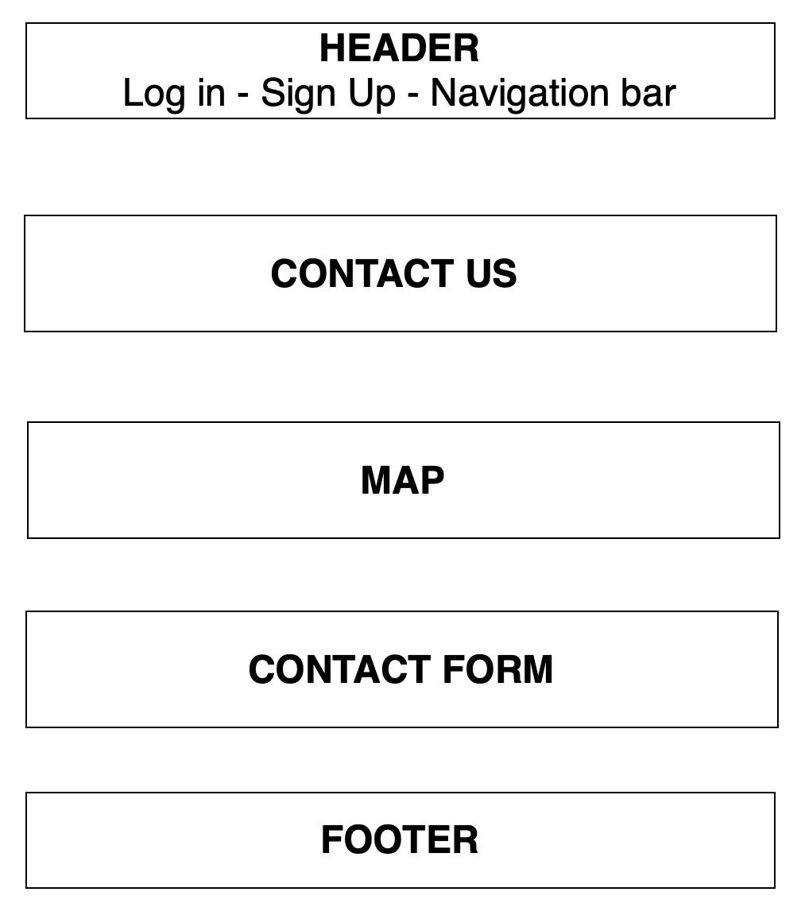

1. **Log in**

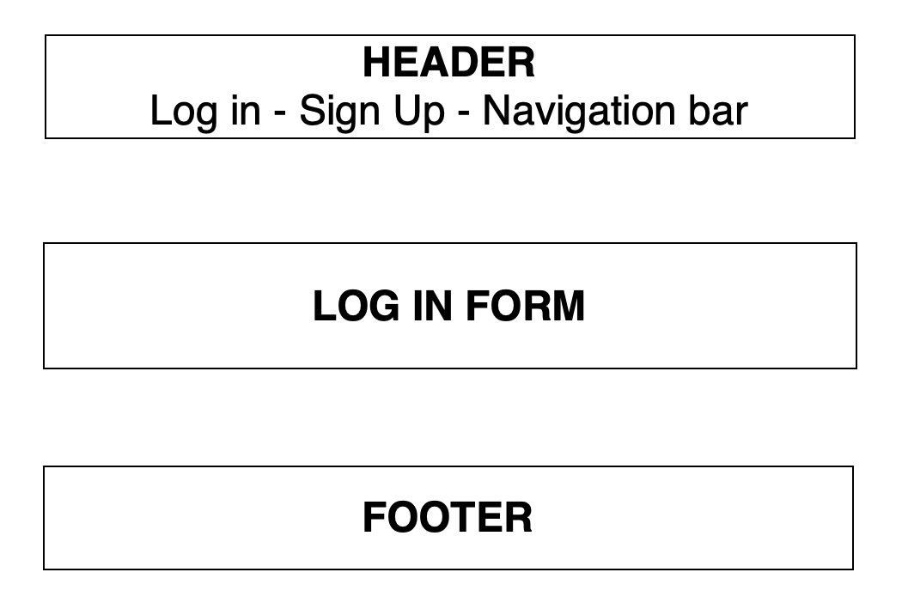

1. **Register**

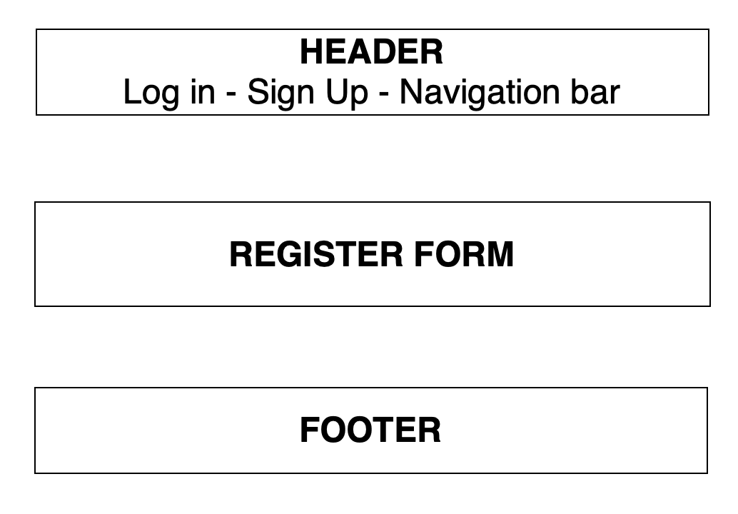



1. **Cart**

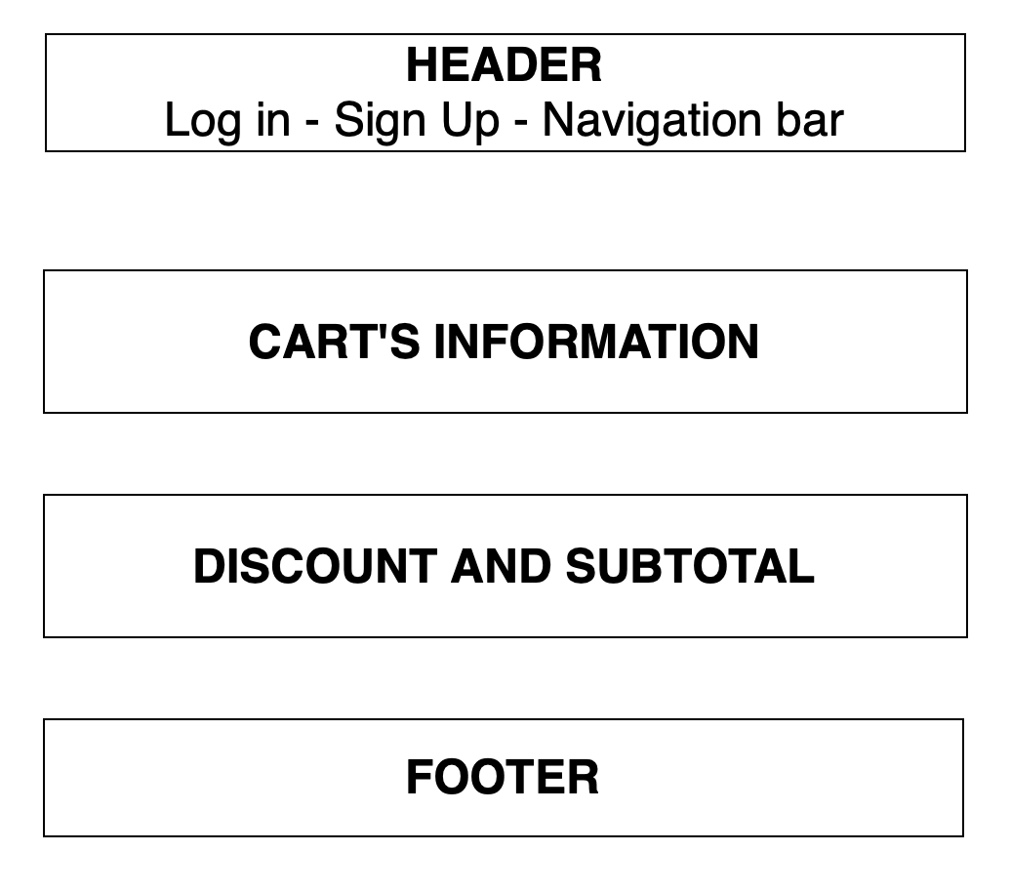

1. **Check out**

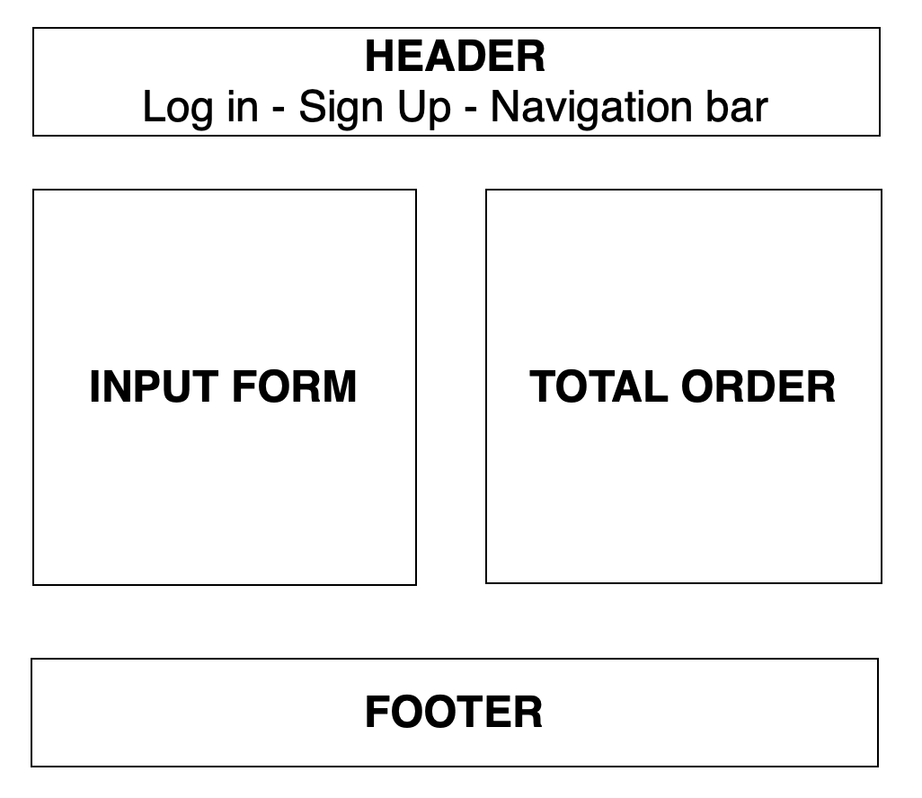

# TASK SHEET REVIEW 2

|  |  |  |  |  |  |  |  |
| --- | --- | --- | --- | --- | --- | --- | --- |
| **Project Ref. No.:**  **eP/Advertisement**  **Portal Management System/01** | | **Project Title:** | **Activity Plan Prepared By:** | **Date of Preparation of Activity Plan:** | | | |
| **Sr.**  **No.** | **Task** | **Actual Start Date** | **Actual Days** | **Team Mate Names** | **Status** |
| 1 | Site map | Rhythm House | Khoa | 18-June-20 | 1 | Dat | Completed |
| 2 | Mock of the website | 18-June-20 | 2 | Khoa | Completed |
| 3 | Task sheet | 18-June-20 | 2 | Huy | Completed |

|  |  |
| --- | --- |
| **Date:** | |
| Signature of Instructor:  **Ms. Le Mong Thuy** | Signature of Team Leader:  **Pham Dang Khoa** |

# WEBSITE DESCRIPTION

1. **Home Page**
2. Description

Home page displays following information:

* Feature product such as new album.
* Latest live show.
* Statistics of album sold.

1. Screen shot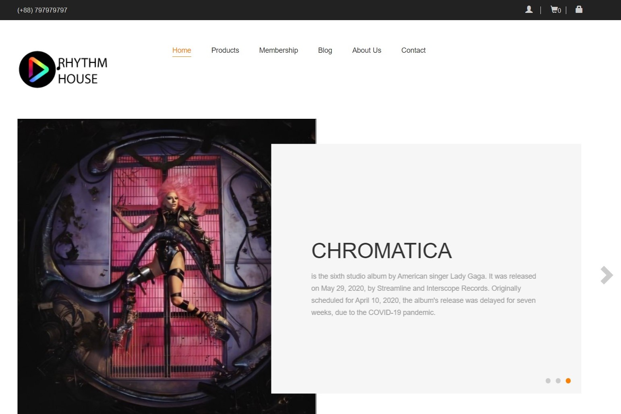

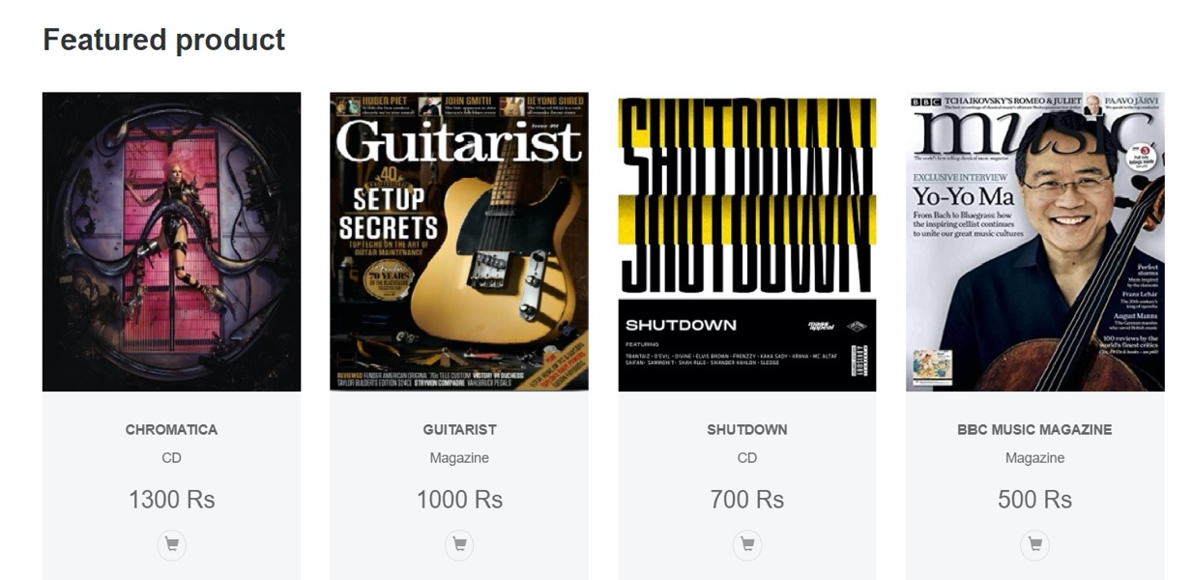



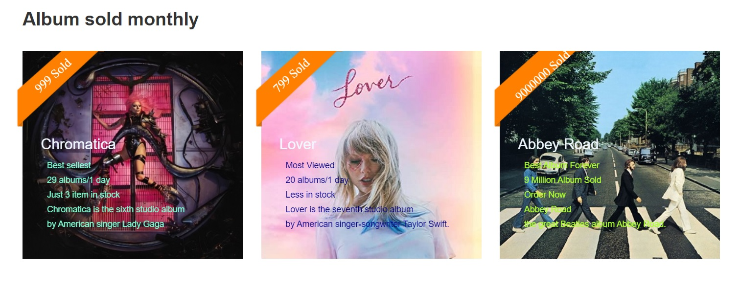

1. **Shop**
2. Description

This shop page displays following information:

* All product that being sold at Rhythm House (CD, DVD, tap, magazine, book), when click on 1 specific item, it will show the detail of that item
* Menu filter and search window to easily find items based on categories.

1. Screen shot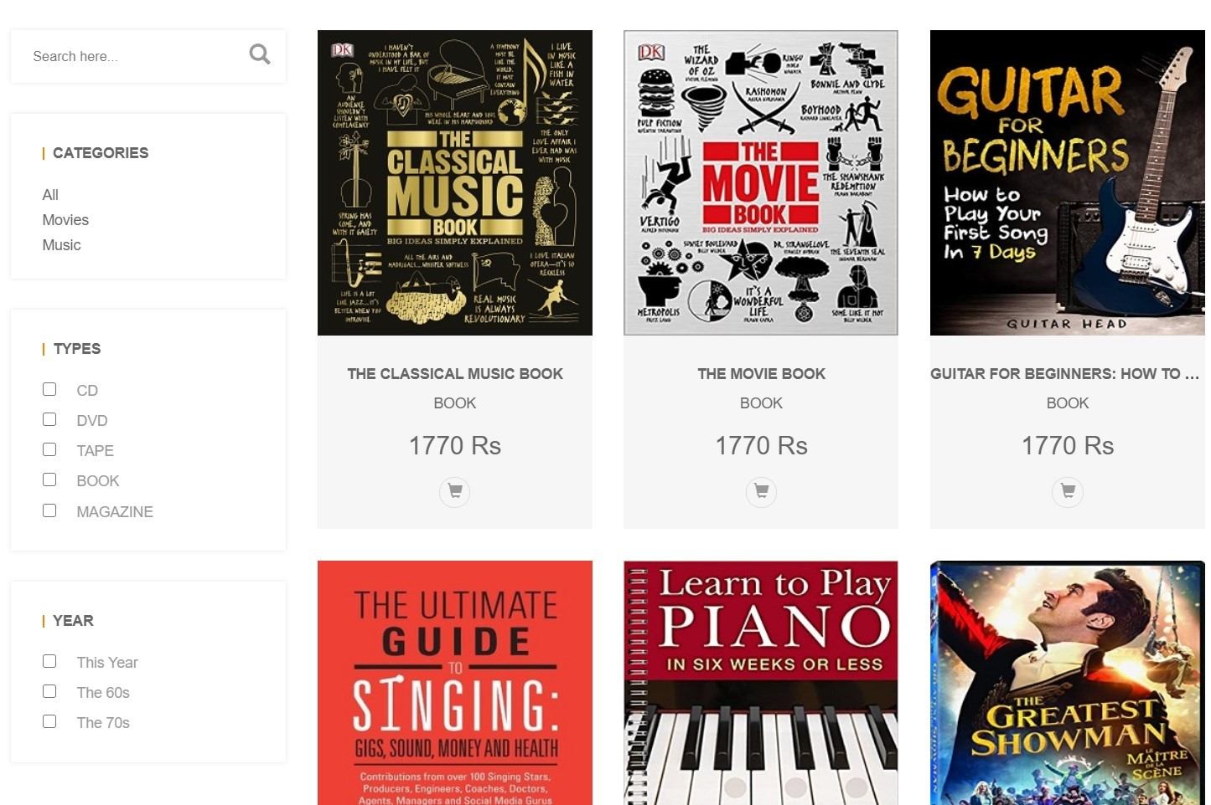

Detail product:

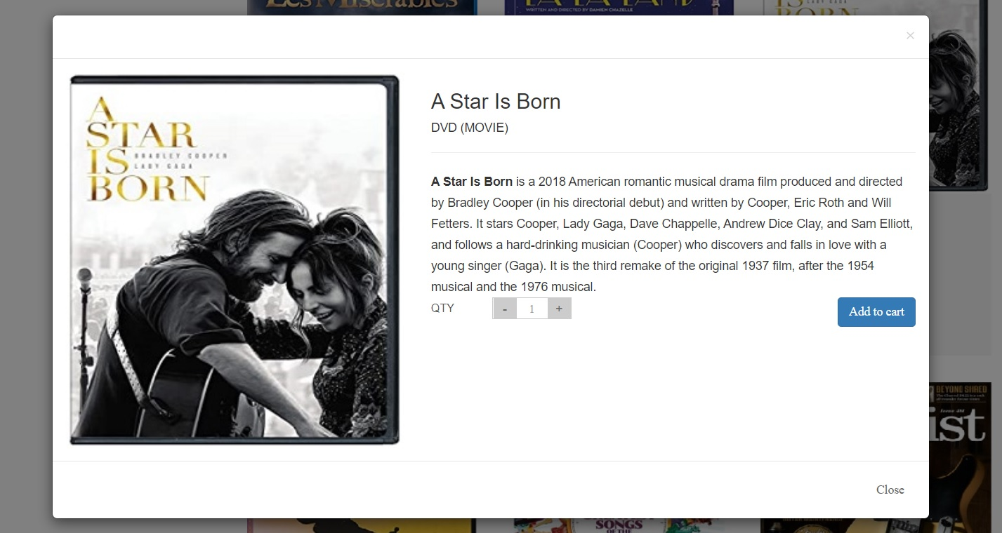

1. **Membership**
2. Description

Membership page display information about our membership program, as well as the point system that they can use to get discount.

1. Screen shot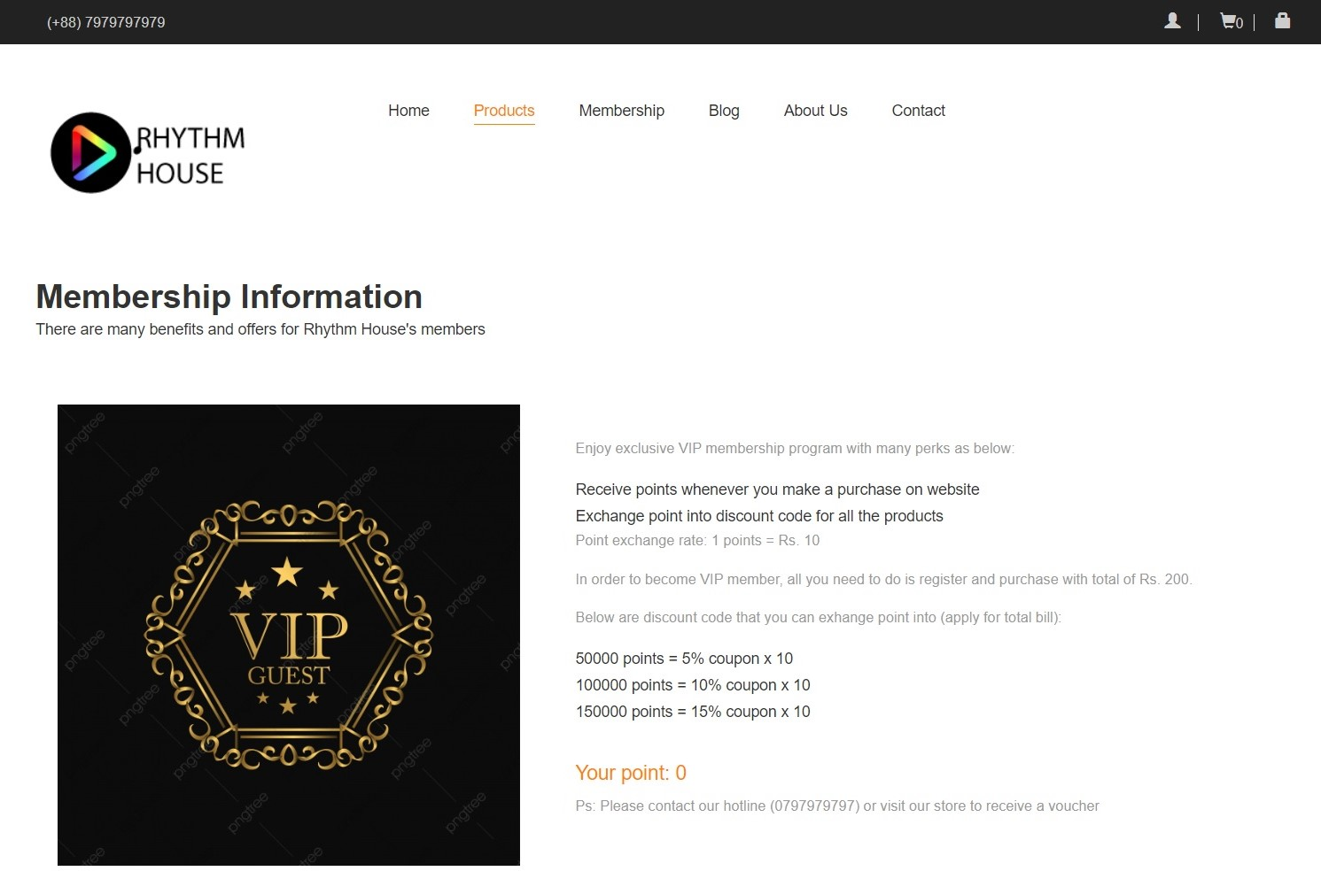
2. **Blog**
3. Description

The blog page displays following information:

* Live show.
* Music contest.
* Events.

1. Screen shot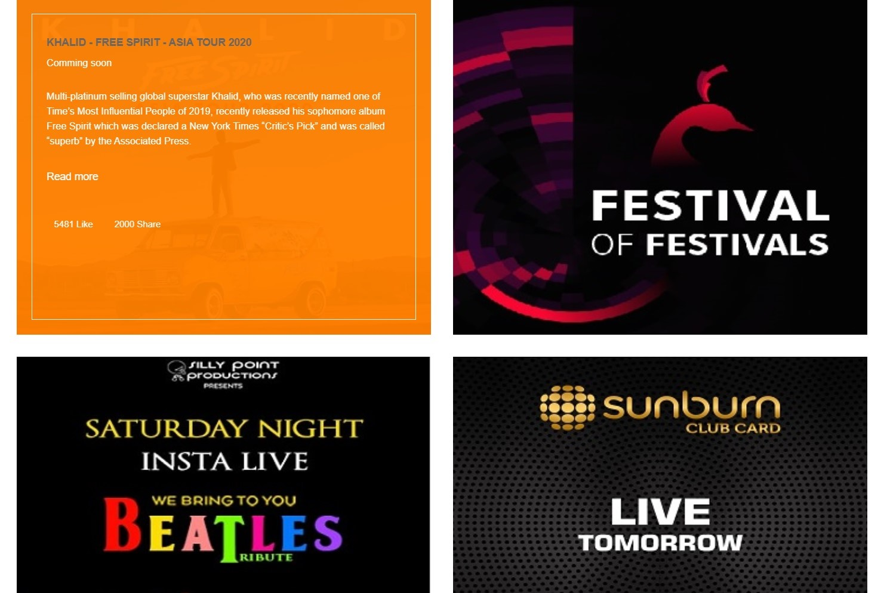

Detail:

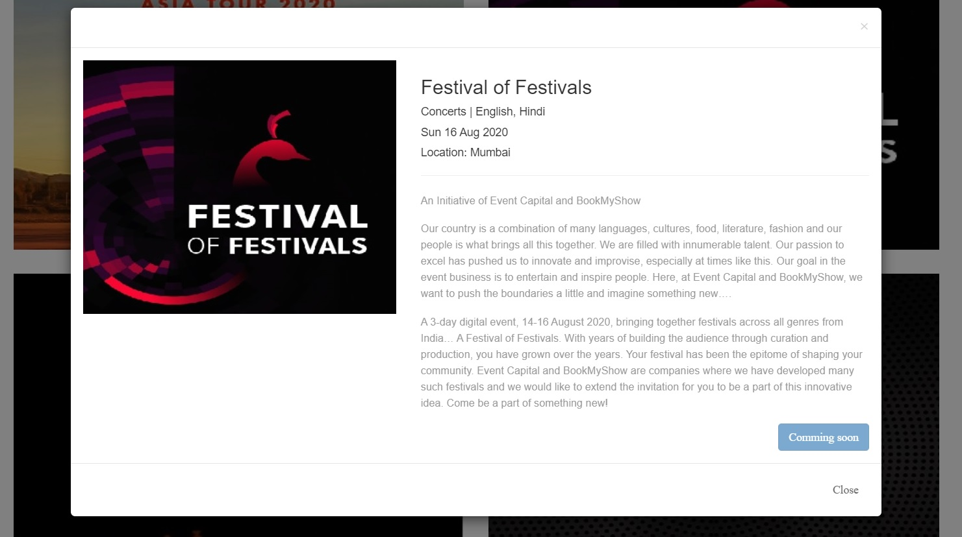

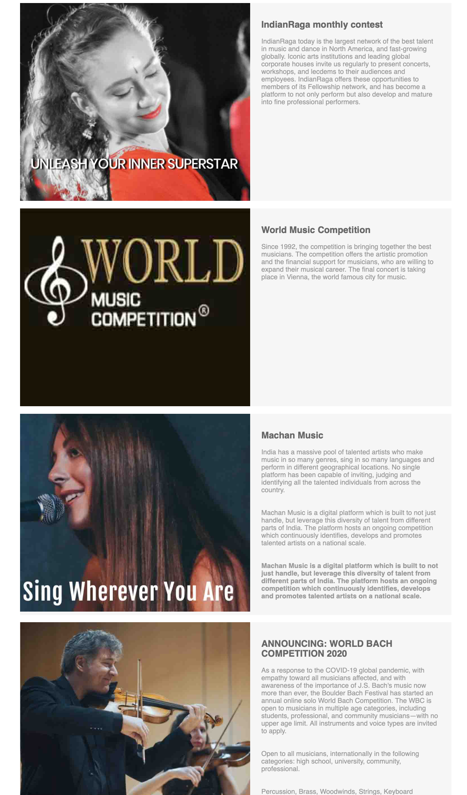

1. **About us**
2. Description

This page displays information about the history of Rhythm House, our service that we provide and our team member.

1. Screen shot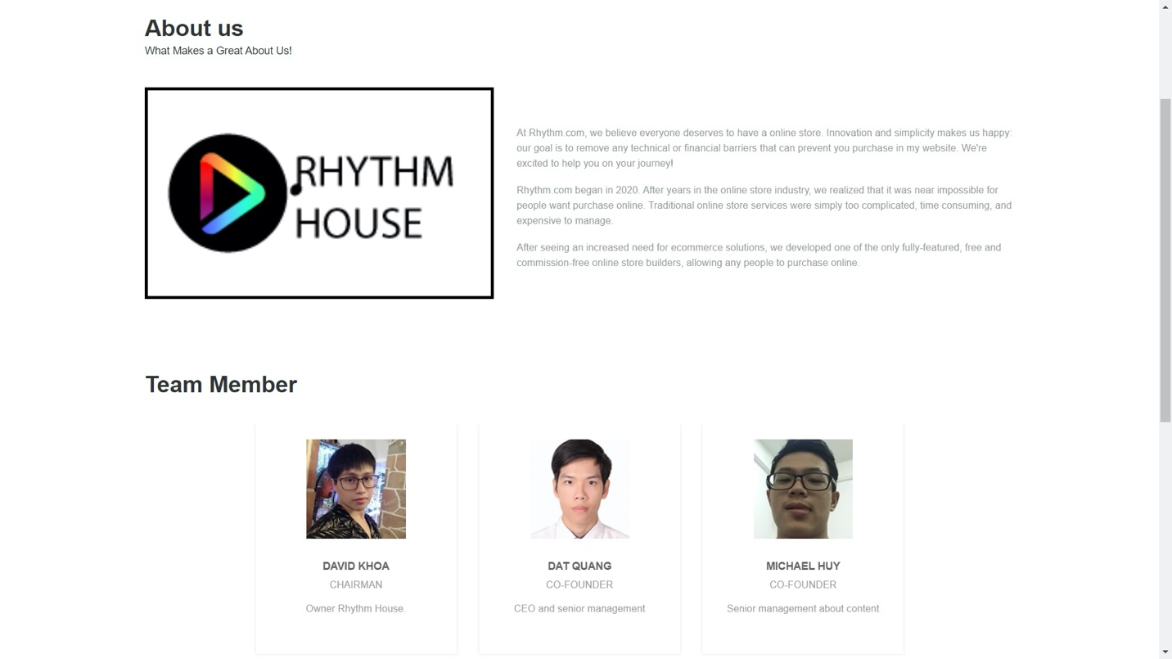
2. **Contact us**
3. Description

This page displays contact information: location, telephone number, email and a quick contact form for customer.

1. Screen shot

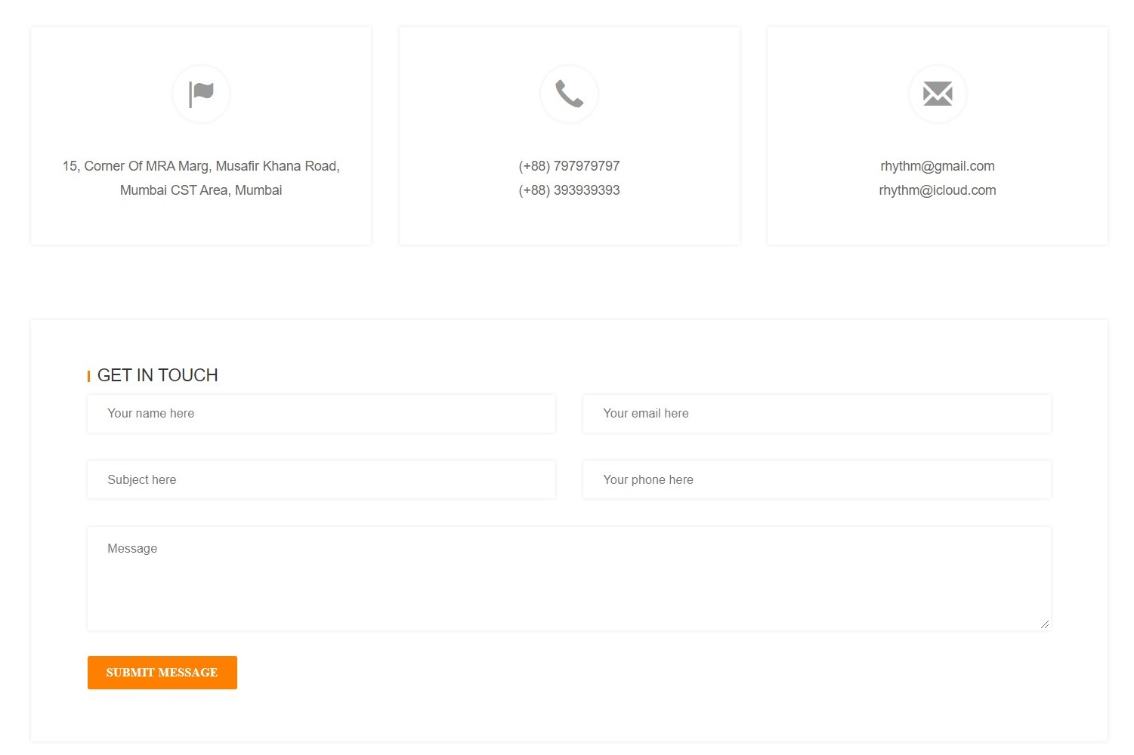

1. **Log in**
2. Description

This webpage displays log in form for customer, it will require email address and password.

1. Screen shot

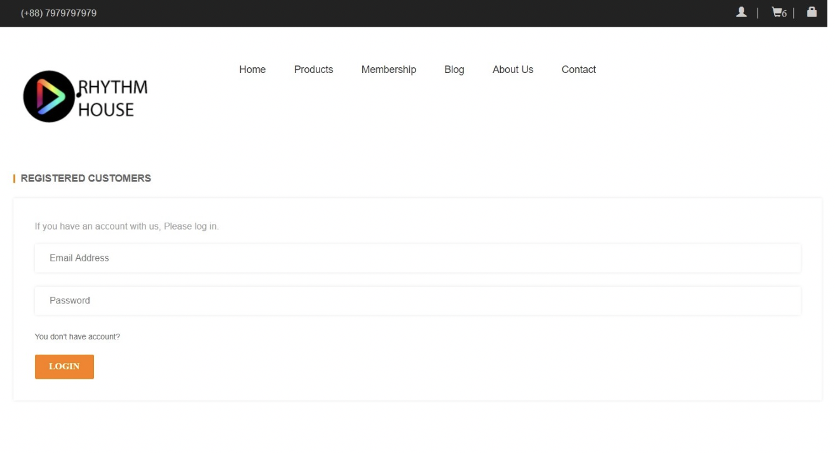

1. **Register**
2. Description

This webpage displays register form allow customer sign up for membership. It will require some information of user such as: first name, last name, phone number, email address and password.

1. Screen shot

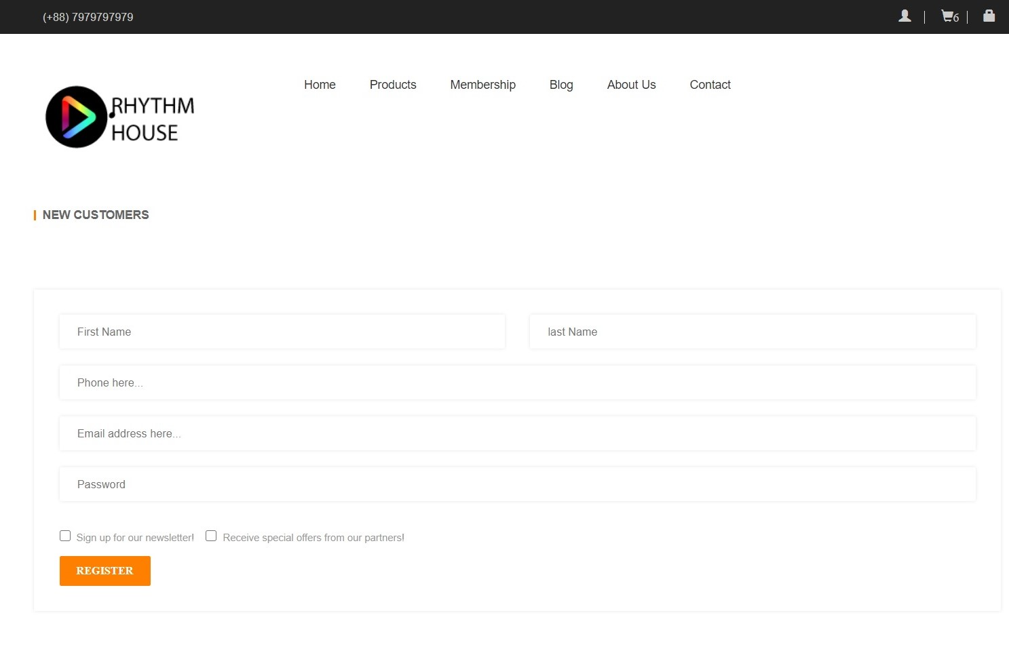

1. **Cart**
2. Description

This webpage displays item that being purchased, quantity and price of each item.

1. Screen shot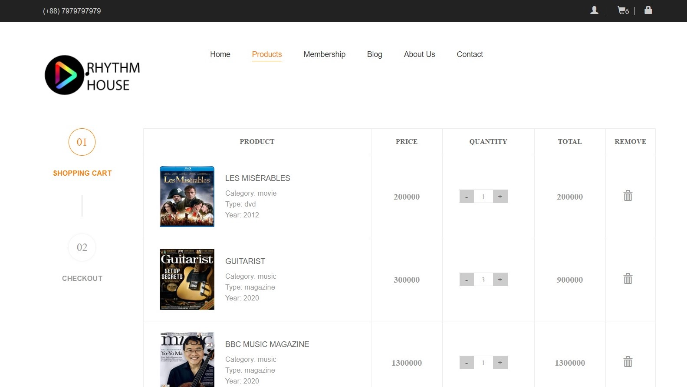
2. **Check out**
3. Description

This webpage displays billing detail and total price of items that we wish to purchase. Upon clicking place order, the purchase order will be placed.

1. Screen shot

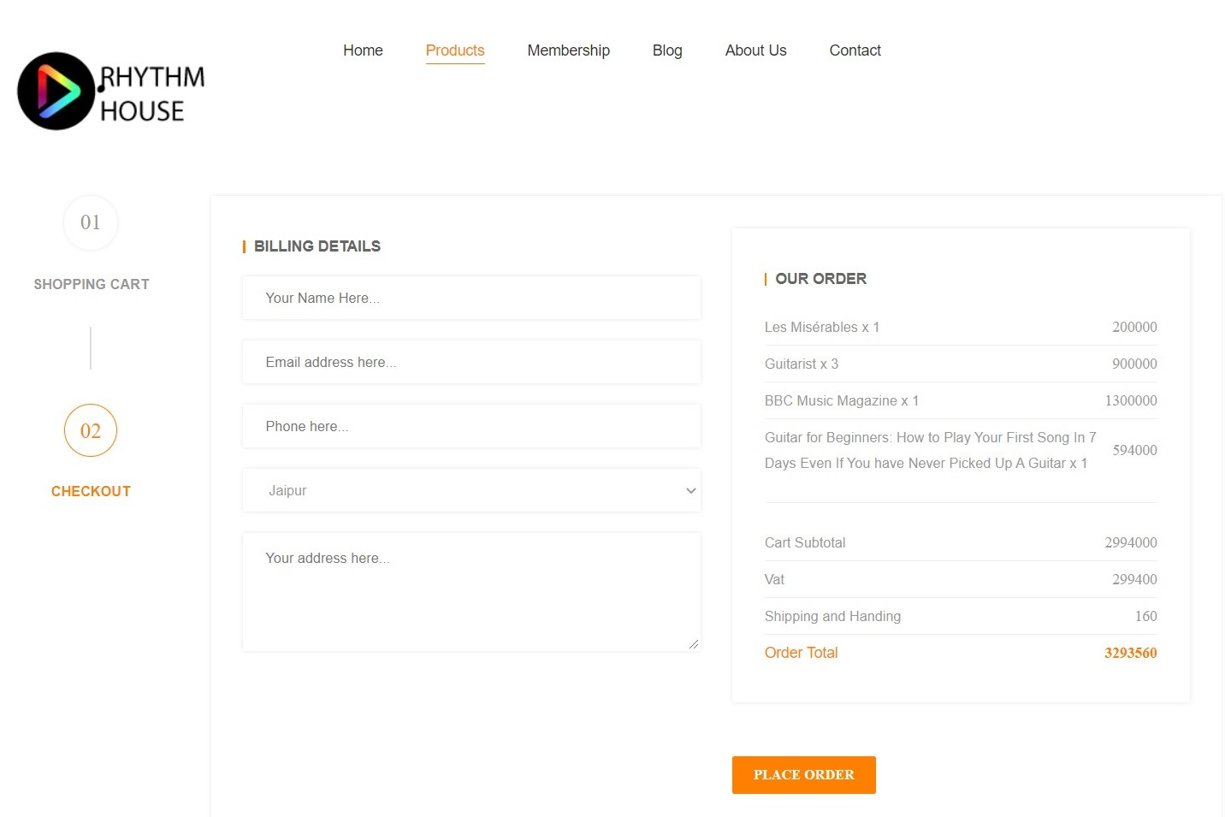

**RESPONSIVE**

The page has responsive feature for small screen device such as smart phone, tablet, etc.

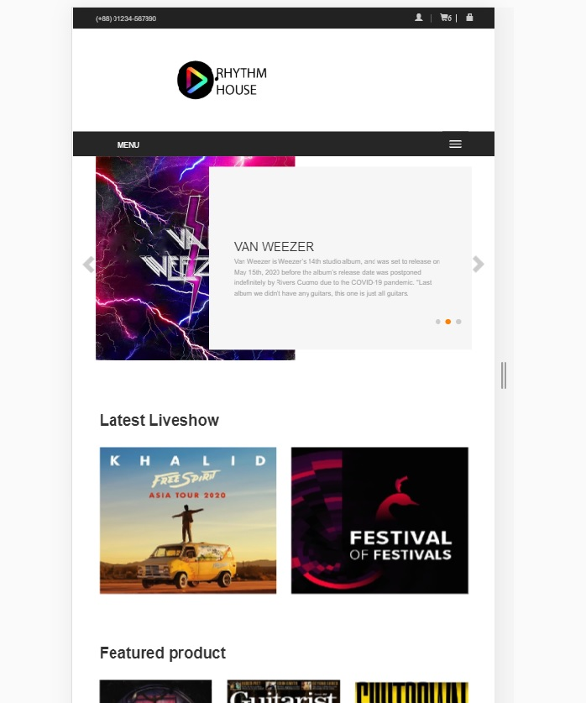

**JAVASCRIPT DESCRIPTION**

1. **Slider javascript**
2. Decrription

This script used slick package (carousel) to display the products on the website.

1. Screen shot

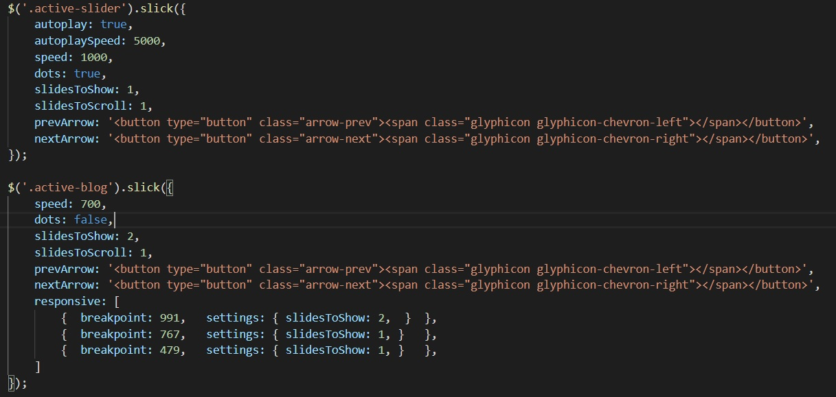

1. **Log in, register Javascript**
2. Description

This script is used for displaying information upon log in or register action.

1. Screen shot

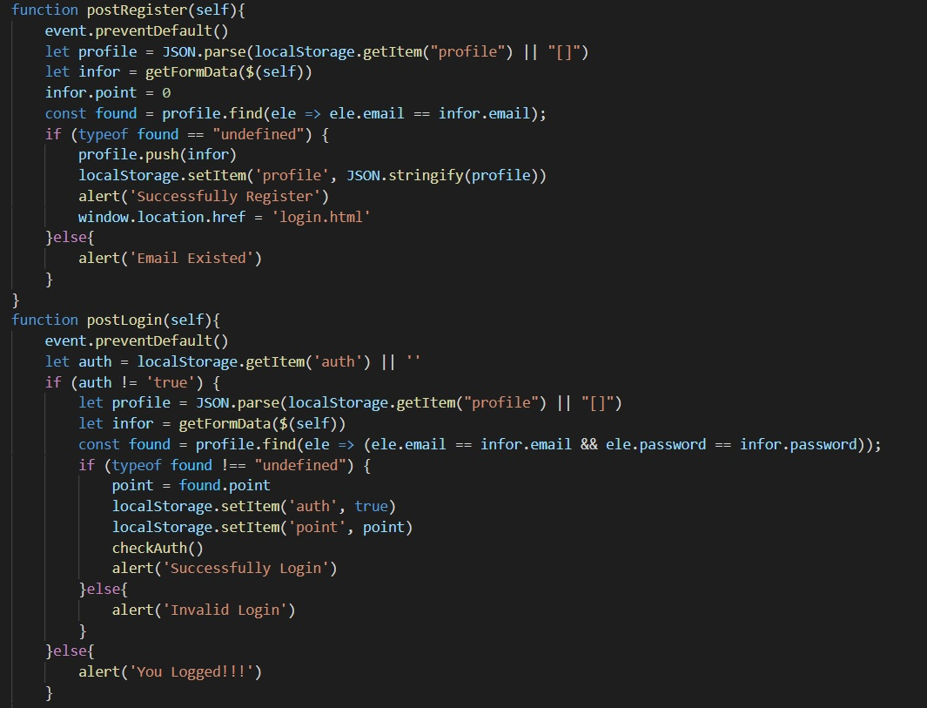

1. **Log out Javascript**
2. Description

This script is used for reloading the page after user has been logged out.

1. Screen shot

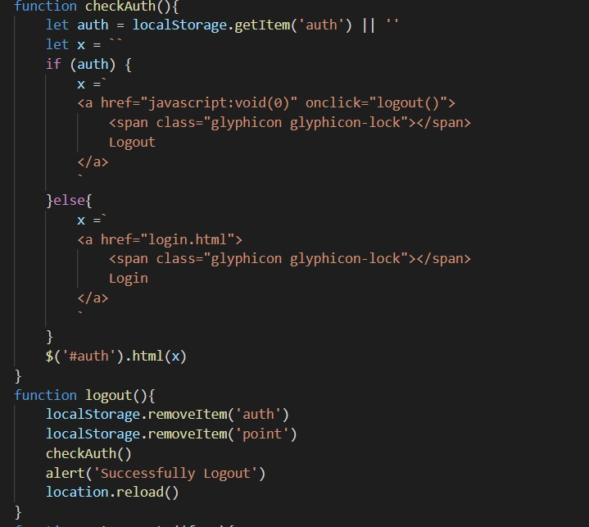

1. **Menu mobile javascript**
2. Description

This script is used for displaying the menu on mobile device.

1. Screen shot

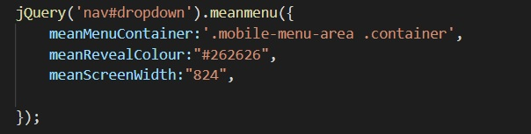

1. **Filter javascript**
2. Description

This script used for filtering items in the shop page based on categories.

1. Screen shot

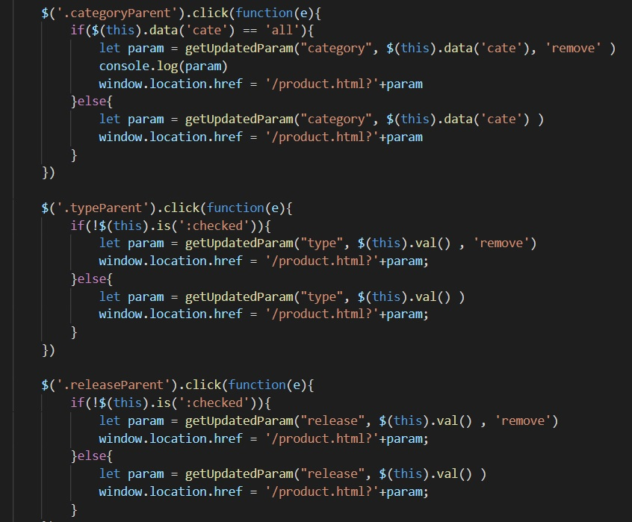

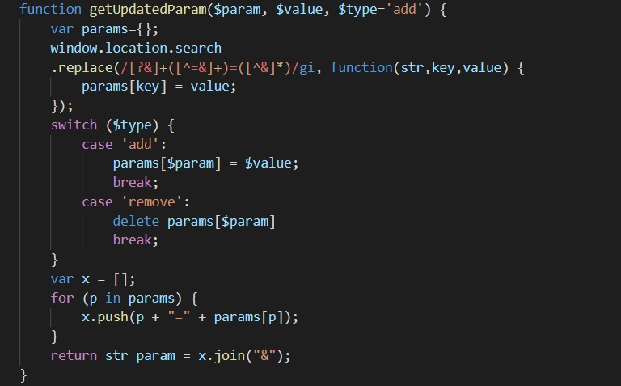

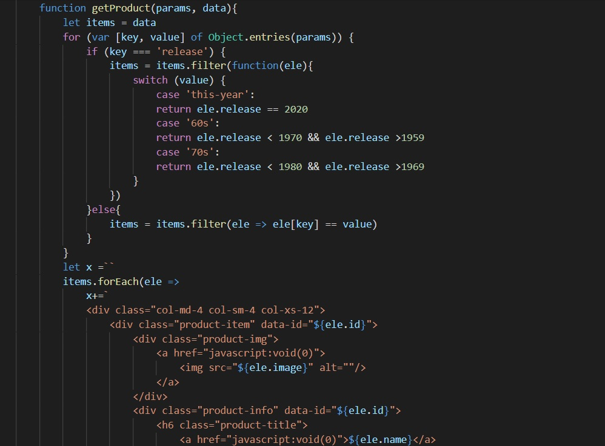

1. **Search Javascript**
2. Description

This script used for search items in the shop page.

1. 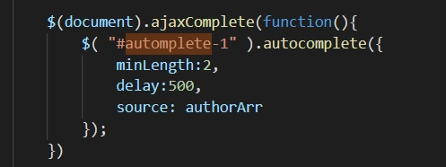Screen shot



1. **Add product to cart javascript**
2. Description

This script used for adding product in cart page.

1. Screen shot

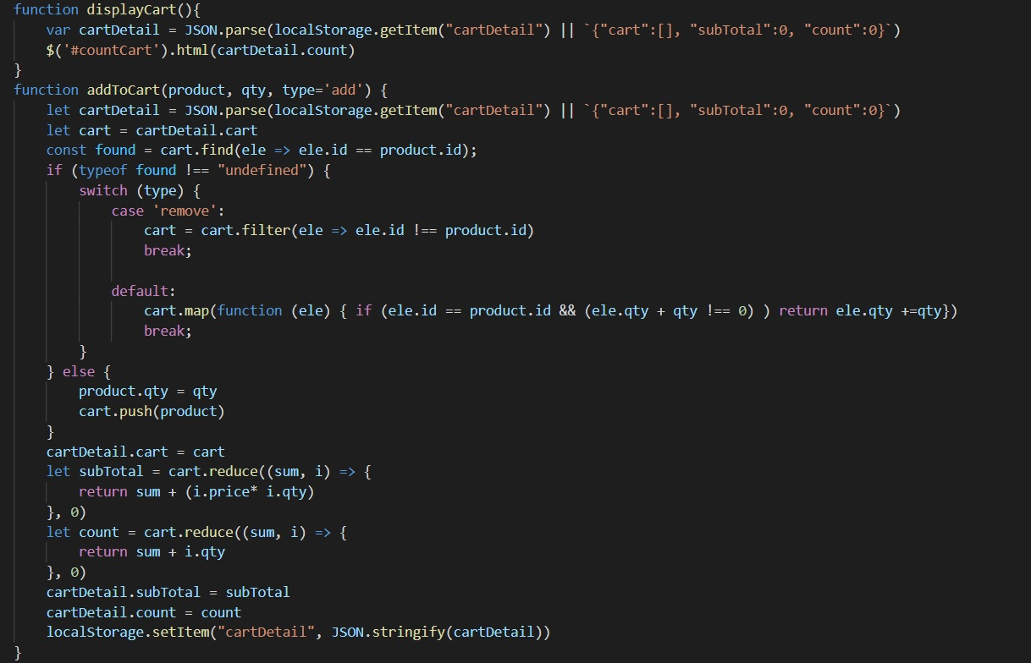

1. **Create modal javascript**
2. Description

This script used for displaying detail of item when clicked.

1. Screen shot

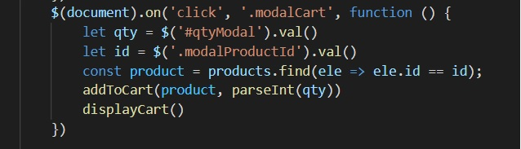

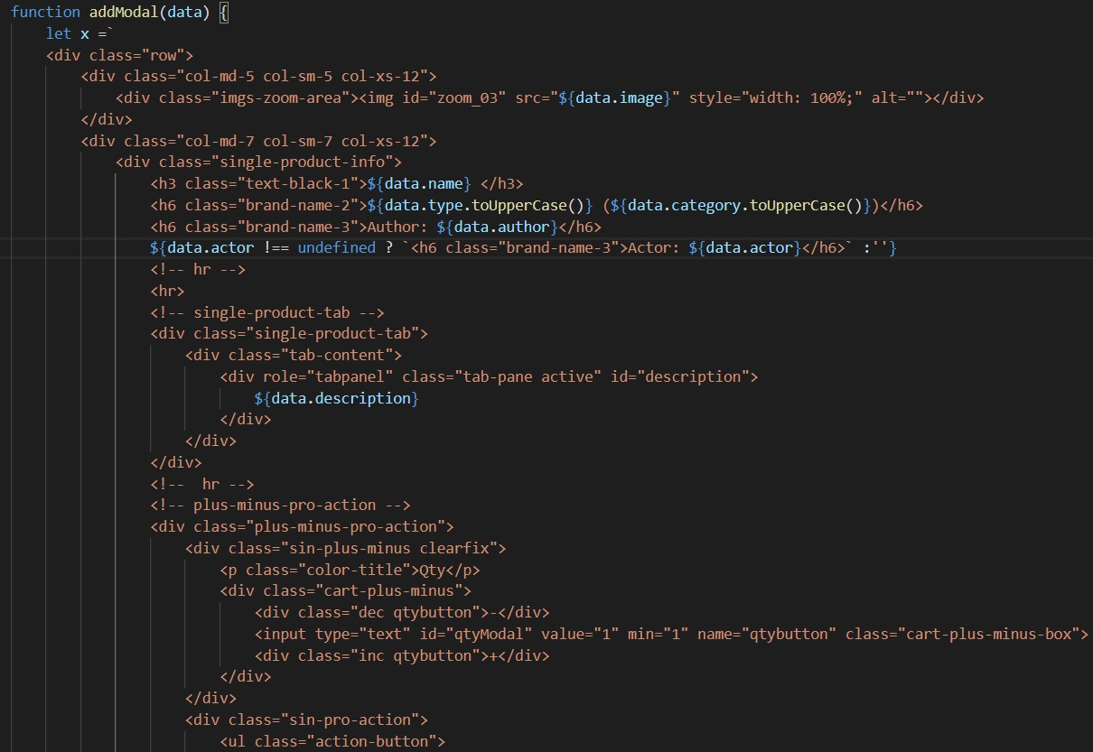

1. **Cart javascript**
2. Description

This script used for display all the items that being purchased.

1. Screen shot

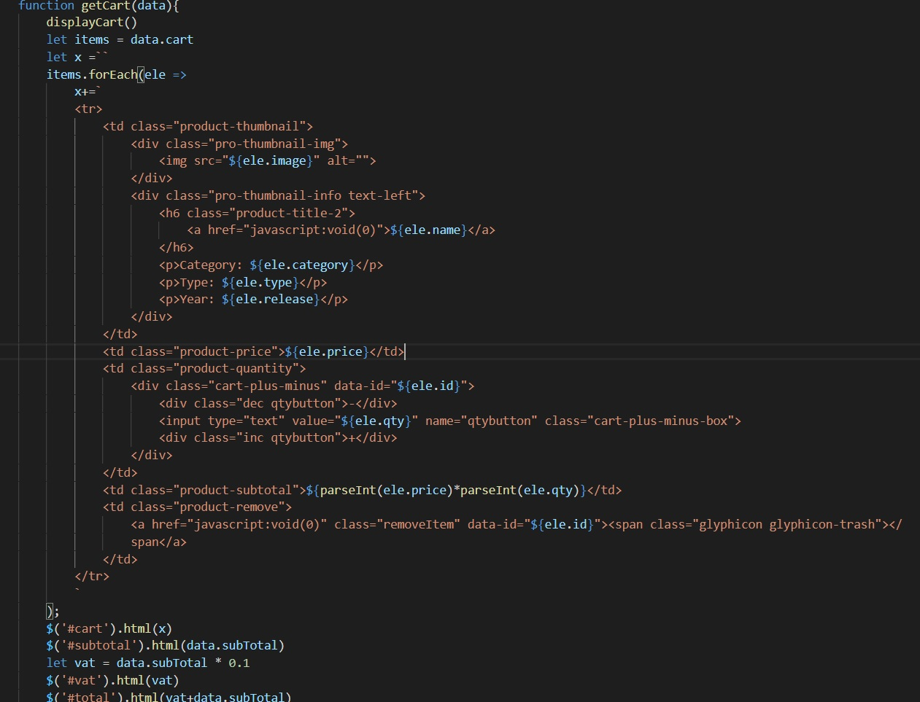

1. **Check out javascript**
2. Description

This script used for display the total items and price in check out page.

1. Screen shot

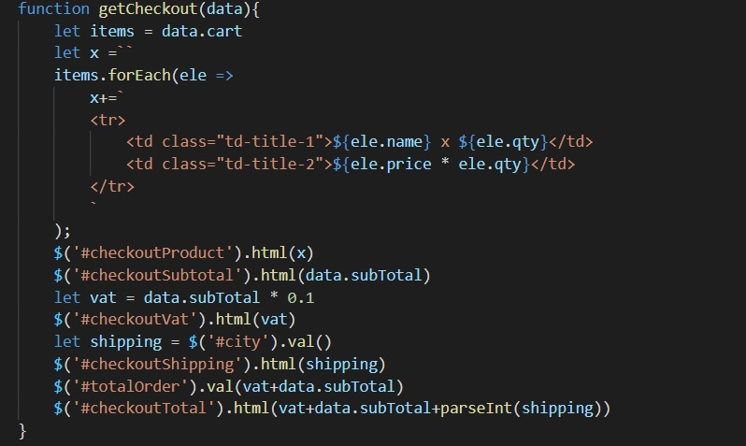

# TASK SHEET REVIEW 3

|  |  |  |  |  |  |  |  |
| --- | --- | --- | --- | --- | --- | --- | --- |
| ***Project Ref. No.:***  ***eP/Advertisement Portal Management System/01*** | | ***Project Title:*** | ***Activity Plan Prepared By:*** | ***Date of Preparation of Activity Plan:*** | | | |
| ***Sr.***  ***No.*** | ***Task*** | ***Actual Start***  ***Date*** | ***Actual Days*** | ***Team Mate***  ***Names*** | ***Status*** |
| *1* | *Home page* | *Rhythm House* | *Khoa* | 02-Jul-20 | *1* | *Khoa* | *Completed* |
| *2* | *Shop* | 03-Jul-20 | *2* | *Khoa* | *Completed* |
| *3* | *Membership* | 05-Jul-20 | *1* | *Khoa* | *Completed* |
| *4* | *Blog* | 02-Jul-20 | *1* | *Khoa* | *Completed* |
| *5* | *About us* | 03-Jul-20 | *1* | *Khoa* | *Completed* |
| *6* | *Contact us* | 04-Jul-20 | *1* | *Huy* | *Completed* |
| *7* | *Log in* | 05-Jul-20 | *1* | *Huy* | *Completed* |
| *8* | *Register* | 06-Jul-20 | *1* | *Huy* | *Completed* |
| *9* | *Cart* |  |  | 07-Jul-20 | *1* | *Huy* | *Completed* |
| *10* | *Check out* |  |  | 02-Jul-20 | *1* | *Dat* | *Completed* |
| *11* | *Responsive* |  |  | 03-Jul-20 | *1* | *Dat* | *Completed* |
| *12* | *Javascript* |  |  | 04-Jul-20 | *1* | *Dat* | *Pending* |
| *13* | *User Guide* |  |  | 05-Jul-20 | *1* | *Dat* | *Pending* |

|  |  |
| --- | --- |
| **Date:** | |
| Signature of Instructor:  **Ms. Le Mong Thuy** | Signature of Team Leader:  **Pham Dang Khoa** |